The 11th Korean Air Future Artist Olympiad Application Form

Classification |  |  |  | □ Individual (One person) □ Group (Two person)
 | Name of Drawing
 | Participant |  |  |  | Application information
 | 1 |  | Full Name |  |  |  |  | Date of Birth
 |  |  | Gender |  | Male / female |  | Nationality
 |  |  | Affiliation |  | Name of School |  | Telephone |  |  | Teacher’s Room
 |  |  | Address of School
 |  |  | Classification  of Guardian |  | □ Teacher □ Parents |  | Name of Guardian
 |  |  | Guardian’s  Contact No.  (Mobile) |  |  |  | Guardian’s  E-mail
2 |  | Full Name |  |  |  | Date of Birth
 |  | Gender |  | Male / female |  | Nationality
 |  | Affiliation |  | Name of School |  | Telephone |  |  | Teacher’s Room
 |  | Address of School
 |  | Classification  of Guardian |  | □ Teacher □ Parents |  | Name of Guardian
 |  | Guardian’s  Contact No.  (Mobile) |  |  |  | Guardian’s  E-mail

I am applying to participate in <The 11th Korean Air Future Artist Olympiad drawing contest>
with the information above.

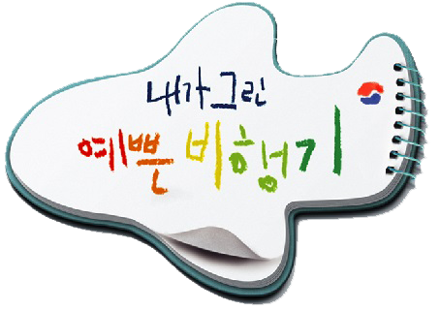
. . 2019

Participant (Signature)

Korean Air Lines Co., Ltd.

[ How to Fill out Application Form ]

1) The participating teams are divided into groups of <One person group> or < two person group >.
2) When applying by mail, please attach this application on the back of the drawing entry after filling it out.
3) After submitting the application, you are not allowed to alter the classification of your participation.
4) Any personal information provided in this application form will not be used for purposes other than
participation in this event.

